IMAGE ENHANCEMENT AND COMPARISON

Q) To what resolution can the image processing software reliably capture data and can we improve upon that value using algorithmic techniques? What additional information that isn’t readily observable can we detect from the images being analyzed?

**Ans:** Image Processing Software's can capture data up to any resolution but the drawback comes in the datatype of the array of data representing the image. For example, In Pillow Library, The datatype required for it to work in integer hence it is mandatory to typecast all your data to integer and then proceed with it While other libraries such as OpenCV or Scikit-Image provides you with the mechanism of dealing with floating point data also.

Other aspect is that, sometimes when the file resolution is too high Pillow library gives a Memory Error, it's because of its own way of handling images. Behind the scenes it’s converting that image into the PIL object and then runs the modification on it. While other libraries first actually convert the image into Numpy.ndarray which is an array of multi-dimensional arrays.

Hence It is easier to enhance and work with the images having very high resolution in Libraries like Scikit-image or NumPy or OpenCV while it is easy to work with images having normal resolution in Pillow Library.

By using Python Libraries, we can detect many features of the image which are not readily observable like its format, size in pixels, mode of the image, its color Pallete.

Enhancing the Images using Pillow Library and comparing them.

Importing the library.



1) Resizing the image:

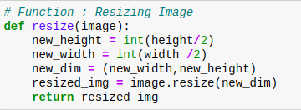

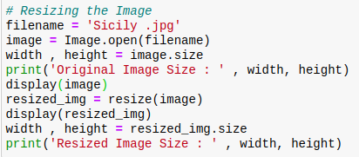

To resize an image, you call the resize() method on it, passing in a two-integer tuple argument representing the width and height of the resized image. The function doesn't modify the used image, it instead returns another Image with the new dimensions.

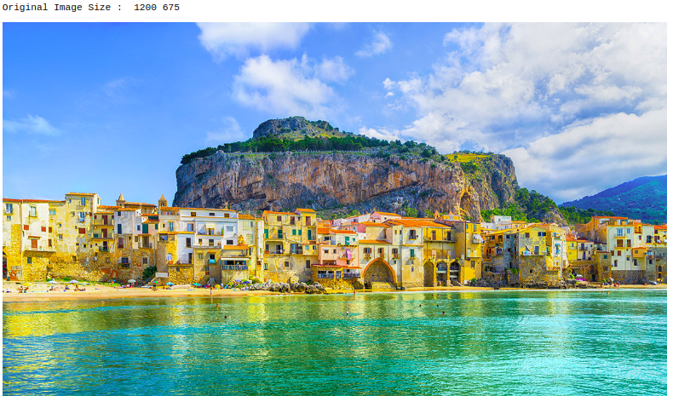

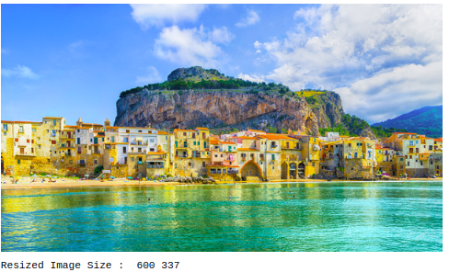

2) Sharpening the Image:

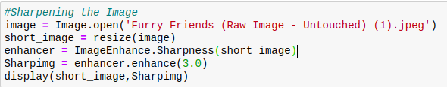

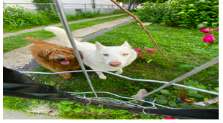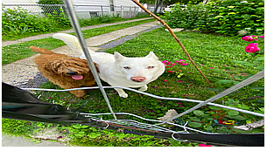

Original Image Sharpened Image

The process of sharpening actually includes subtracting a blurred (unsharp) copy of the image from the original image to detect any edges. A mask is made with this edge detail. Contrast is then increased at the edges and the effect is applied to the original image.

Hence, we can see that the sharpened images have better edges which we can differentiate from the original image where it's all blurry.

3) Enhancing the Color Saturation:

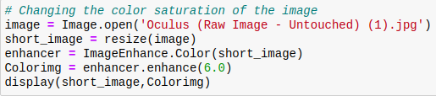

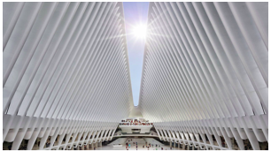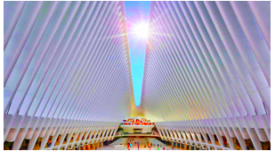

Original Image Color Saturated Image

This Color saturation techniques basically modifies the intensity of each color in the image. As the saturation increases, color appears purer. So internally it's just increasing the intensity of each and every pixel's color.

So Here we can notice that all the color intensities of the color saturated image is more than that of original image making it much easier to distinguish between colors.

4)Enhancing the contrast of the image:

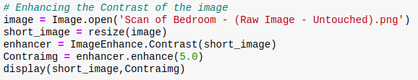

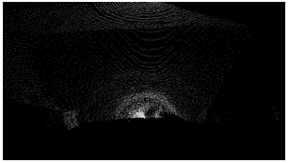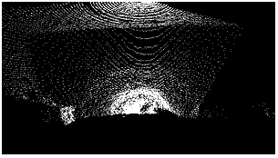

Original Image High Contrast Image

Contrast is defined as the separation between the darkest and brightest areas of the image. Increase contrast and you increase the separation between dark and bright, making shadows darker and highlights brighter. So internally its checking the difference making the light lighter and the dark darker.

Here the high contrast image has higher difference in the pixel colors than in original image making it much better to look.

5) Enhancing the Brightness of the image:

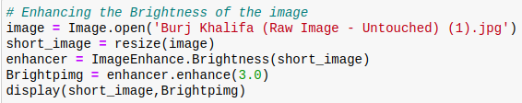

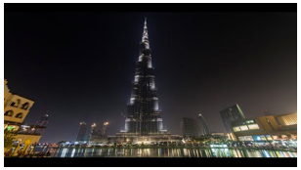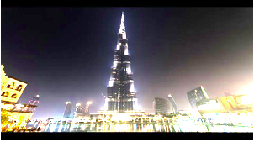

Original Image Brighter Image

Brightness refers to the overall lightness or darkness of the image. Increasing the brightness every pixel in the frame gets lighter. So internally its going over pixel by pixel and then increasing its intensity to the given brightness factor.

Here the Brighter image has all its pixels intensity increased and hence it is greater than the pixel intensity of the original image.